
SOFTWARE REQUIREMENTS SPECIFICATION
for
HEALTH DATA BANK
Final Assignment - Final Submission
Topic Name: Health Data Bank
Short Description: The Health Data Bank is a secure and centralized digital healthcare system designed to store, manage, and share citizens' lifelong medical records. Each patient receives a unique Health ID linked to the National ID. The system supports patients, doctors, medicine shopkeepers, diagnostic centers, researchers, and administrators through role-based access control while ensuring privacy, security, availability, and continuity of healthcare services.

Group Number: 4
Section: C
Group Members
Name | ID
MD.Mahamodul Hasan Taj | 22-47271-1
MD.AHANAF TAJWARE ABIR | 22-49718-3
Sadia Islam koli | 20-43208-1

Course Title: Software Requirement Engineering
Course Code: 00963
Semester: Summer 2025-2026

Member Contribution
The final SRS was completed collaboratively. The responsibilities below document the major tasks completed by each member and the agreed contribution distribution.
MD.Mahamodul Hasan Taj — 22-47271-1 (40%)
• Led final SRS compilation, structure checking, requirement integration, and submission preparation.
• Prepared and refined the system-feature requirements, nonfunctional requirements, data requirements, and final appendices.
• Prepared and integrated the updated UI prototype screens for the final submission.
• Prepared, organized, and finalized the Use Case Diagram, Class Diagram, Activity Diagram, and E-R Diagram.
• Performed final document review, formatting verification, diagram placement, and consistency checking.
MD.AHANAF TAJWARE ABIR — 22-49718-3 (30%)
• Completed and reviewed major parts of the Introduction and Overall Description content.
• Contributed to user classes, operating environment, implementation constraints, and assumptions/dependencies.
• Assisted with requirement checking, references, and consistency review across the SRS.
Sadia Islam Koli — 20-43208-1 (30%)
• Contributed to requirement analysis, supporting descriptions, quality requirements, and final review.
• Assisted with interface-related content, glossary/other-requirement checks, proofreading, and completeness verification.
• Participated in final content validation and submission-readiness checking.

Table of Contents
Member Contribution | 2
1. Introduction | 4
1.1 Purpose | 4
1.2 Document Conventions | 4
1.3 Project Scope | 4
1.4 References | 5
2. Overall Description | 5
2.1 Product Perspective | 5
2.2 User Classes and Characteristics | 6
2.3 Operating Environment | 8
2.4 Design and Implementation Constraints | 9
2.5 Assumptions and Dependencies | 10
3. System Features | 11
3.1 Software Login | 11
3.2 User Role Management | 11
3.3 Logout | 12
3.4 Admin Profile Management | 12
3.5 Admin Role Management | 13
3.6 User Account Management (Admin) | 13
3.7 System Monitoring and Reports (Admin) | 14
3.8 Patient Profile Management | 14
3.9 Medication Reminder System | 15
3.10 Doctor Profile Management | 15
3.11 Shopkeeper Profile Management | 16
3.12 Researcher Profile Management | 16
3.13 Prescription Management | 16
3.14 Diagnostic Report Upload | 17
3.15 Research Data Access | 17
3.16 Emergency Alerts and Notifications | 18
4. Data Requirements | 18
4.1 Logical Data Model | 18
4.2 Data Dictionary | 20
4.3 Reports | 21
4.4 Data Acquisition, Integrity, Retention and Disposal | 22
5. External Interface Requirements | 22
5.1 User Interfaces | 22
5.2 Hardware Interfaces | 27
5.3 Software Interfaces | 27
5.4 Communications Interfaces | 28
6. Quality Attributes | 28
6.1 Usability | 28
6.2 Performance | 28
6.3 Safety | 29
6.4 Security | 29
6.5 Reliability, Availability, Scalability, Maintainability and Portability | 29
7. Internationalization and Localization Requirements | 30
8. Other Requirements | 30
8.1 Database Requirements | 30
8.2 Legal and Regulatory Requirements | 30
8.3 Backup, Recovery, Audit and Compliance | 31
8.4 Project Requirements and Management | 31
Appendix A: Glossary | 31
Appendix B: Analysis Models | 32
Appendix C: To Be Determined List | 35
Revision History
Name | Date | Reason For Changes | Version
Group 4 | 01-08-2026 | Section 1 and Section 2 submission prepared | 1.1
Group 4 | 29-08-2026 | Full SRS completed with updated UI prototypes and analysis models | 2.0

1. Introduction

1.1 Purpose
The purpose of the Health Data Bank is to:
- Issue a unique Health ID to every citizen, linked with their National ID, for centralized medical tracking.
- Enable secure, role-based access, so healthcare professionals and pharmacists access only the data they need, with doctor access requiring patient consent via Health ID scan.
- Digitally consolidate lifelong health records, replacing paper files and unifying patient data across public and private facilities.
- Protect patient data through encryption, authentication (PIN/biometrics), and ongoing audits.
- Support public health and research by providing anonymized, de-identified datasets while preserving individual privacy.

1.2 Document Conventions
This software requirement specification (SRS) for "Health Data Bank" adheres to a standardized set of standards and typographical norms to ensure clarity and consistency throughout the text.
• Font Style and Size: Times New Roman, 12-point size, with 1.0 line spacing and justified alignment is used throughout the document for a clean and professional appearance.
• Bold text: Important terms (e.g., User Roles, Health ID, Anonymized Data) and section headers are bolded to highlight key concepts and improve readability.
• Bullet Point: Bullet points are used to present lists and grouped information clearly and concisely, aiding quick comprehension.
• Preconditions and Postconditions: Where applicable, functional requirements include clearly defined preconditions (what must be true before a function executes) and postconditions (the expected state after execution).
• Cross-Referencing: All internal references to related sections, tables, and figures are made using section numbers (e.g., "See Section 4.2.1") to enhance navigability.
Numbering Convention:
- The SRS document for "Health Data Bank" used a numbered sequence style to organize sections and subsections in a clear, logical, and transparent manner.
- Top-Level Sections, such as Introduction, Overall Description, and Specific Requirements, are represented by single numbers (e.g., 1, 2, 3).
- Subsections within each main section are numbered hierarchically (e.g., 1.1, 1.2, 1.3) to show their relationship to the section.
- Subsequent subdivisions (e.g., 1.2.1, 1.2.2) provide additional clarity and information.
- This design facilitates easy reference and traceability, allowing stakeholders to discover and discuss specific content inside the document.

1.3 Project Scope
The Health Data Bank is a secure, centralized digital system designed to manage and share citizens medical records using a unique Health ID linked to the National ID.
- Provides centralized storage and retrieval of lifelong health records.
- Supports role-based access for patients, doctors, shopkeepers, researchers, and administrators.
- Enables digital prescriptions, diagnostic report management, and appointment scheduling.
- Ensures data privacy through encryption, user consent, and audit logging.
- Supports anonymized data access for research and public health analysis.
- Aligns with national healthcare digitization and e-governance goals.

1.4 References
My Health Record - Australia: https://www.myhealthrecord.gov.au
Description: My Health Record is Australia’s national digital health record system, managed by the Australian Digital Health Agency. It allows citizens to securely store, view, and share their medical history, prescriptions, pathology results, and immunizations with healthcare providers. Users have full control over privacy settings.
ABHA (Ayushman Bharat Health Account) - India: https://healthid.ndhm.gov.in
Description: ABHA is part of India’s Ayushman Bharat Digital Mission (ABDM), designed to give every citizen a unique Health ID to link and access their medical records across healthcare facilities.
1LIFE Health Record - South Africa: https://www.1life.co.za/1lifepulse
Description: 1Life Pulse offers a health management platform linked with wearable data and medical records in South Africa. Though more commercial, it is being integrated with national e-health ambitions.
HealthHub - Singapore: https://www.healthhub.sg
Description: A digital health platform by Singapore’s Ministry of Health and the Health Promotion Board, HealthHub provides access to personal health records, appointments, lab results, immunization records, and health guides.

2. Overall Description

2.1 Product Perspective
Problem Background
In Bangladesh and many other developing nations, patient medical data is fragmented across multiple uncoordinated systems, often stored in paper-based formats or isolated digital platforms without standardization or centralized access. This results in repetitive medical tests, lack of treatment continuity, prescription fraud, and difficulties in managing nationwide health data during emergencies or epidemics. Moreover, current systems lack the infrastructure for secure data sharing or research-based analysis while maintaining patient privacy.
Context and Origin
The Health Data Bank is a new, self-contained system designed to address these systemic limitations by providing a national level, encrypted digital health data platform. It is not a part of any previous system or product family but has been conceptualized in response to government healthcare digitization efforts and rising demand for a centralized, secure health data solution. It integrates multiple stakeholders. Like doctors, patients, shopkeepers, and researchers into a unified framework with role-based access and security protocols.
The system also involves physical components, such as a scannable Health ID card (linked to the National ID), which acts as a secure key for accessing medical data. The scanning can be done using standard smartphones equipped with the application. Although standalone, this platform can be extended to integrate with national e-health programs, prescription validation systems, insurance databases, and future research portals.
Business Objectives
- Centralize and Standardize Medical Records: Create a single source of truth for every patient’s health data accessible securely from any healthcare provider within the system.
- Ensure Patient Privacy: Use advanced encryption and anonymization techniques to protect personal health information while enabling its use in research.
- Reduce Fraud and Errors: Prevent misuse of prescriptions and medical history through identity-linked verification systems.
- Enhance Research Opportunities: Provide researchers with anonymized treatment data for analytics and public health studies without compromising privacy.
- Support Government Health Management: Enable policy makers and health departments to make informed decisions based on aggregate health data trends.

2.2 User Classes and Characteristics

1. Patients
Characteristics:
• Frequency of Use: Infrequent users (e.g., for check-ups, appointments, or medical record updates).
• Subset of Functions: Can view personal medical data, prescriptions, and self-test results.
• Technical Expertise: Low; users are generally non-technical and will need simple interfaces.
• Security/Privilege Levels: Limited to accessing and updating only their own data (high privacy).
• Educational Level/Experience: Varies, but no technical knowledge is required.
Importance:Primary Focus: Patients are the core beneficiaries of the Health Data Bank system. Ensuring their privacy, data security, and ease of use is crucial to the system’s adoption and success. Their ability to access their own health data increases transparency and patient autonomy.

2. Doctors
Characteristics:
• Frequency of Use: Frequent users (use the system daily to manage patient data, prescriptions, and diagnostics).
• Subset of Functions: Full access to medical histories, prescriptions, and the ability to add diagnostic test results and treatment details after scanning the patient id or QR code.
• Technical Expertise: Moderate; doctors may not be highly technical but need to understand medical data systems.
• Security/Privilege Levels: High access, allowing full interaction with patient data.
• Educational Level/Experience: Medical professionals with minimal technical expertise but familiar with digital health tools.
Importance:Key Role: Doctors are integral to the system’s daily function. They are responsible for managing and updating patient health records, making them central to ensuring the accuracy and timeliness of medical data. Their engagement is vital for the system’s clinical success and reliability.

3. Medicine Shopkeepers
Characteristics:
• Frequency of Use: Frequent users (daily interaction to verify prescriptions and dispense medications).
• Subset of Functions: Access prescription details to ensure accurate medication dispensing.
• Technical Expertise: Moderate; they need to operate a basic system interface to verify prescriptions and dispense medications.
• Security/Privilege Levels: Limited access to prescriptions only, without access to full patient data.
• Educational Level/Experience: No technical expertise required, though basic pharmacy knowledge is essential.
Importance:Crucial Support Role: Medicine shopkeepers ensure the correct dispensing of prescribed medications, which directly impacts patient health outcomes. Their interaction with the system is vital for the seamless operation of medication distribution, making them a key user group in maintaining health data accuracy.

4. Diagnostic Centers
Characteristics:
• Frequency of Use: Frequent users (daily uploads of diagnostic results, such as lab reports and X-rays).
• Subset of Functions: Ability to upload diagnostic reports and view medical histories relevant to those reports.
• Technical Expertise: Moderate; familiarity with data entry and integration tools for diagnostics.
• Security/Privilege Levels: High access to diagnostic data but restricted from altering patient medical records.
• Educational Level/Experience: Medical or laboratory professionals with moderate technical skills.
Importance:Supportive Clinical Role: Diagnostic centers play an important role in delivering accurate medical results that inform treatment. Their ability to upload and share diagnostic information ensures timely and accurate care, making them essential for the overall functioning of the system.

5. Researchers
Characteristics:
• Frequency of Use: Occasional users (access anonymized data for research purposes).
• Subset of Functions: Full access to anonymized treatment data, research insights, and statistical analysis tools.
• Technical Expertise: High; they must be adept at using research tools and analyzing large datasets.
• Security/Privilege Levels: High, but access is strictly limited to anonymized data for privacy and ethical reasons.
• Educational Level/Experience: Researchers in medical, healthcare, or data science fields.
Importance:Secondary Role: Researchers enable medical and health-related breakthroughs by using anonymized data. While they do not interact with patient information directly, their access to aggregated data is crucial for public health research and medical innovations. Their involvement helps in advancing the medical field.

6. Administrators
Characteristics:
• Frequency of Use: Frequent users (manage system functionality, user roles, and data security).
• Subset of Functions: Full access to the system for maintaining records, managing users, ensuring data integrity, and overseeing security measures.
• Technical Expertise: High; administrators need advanced technical skills to manage backend systems, databases, and security protocols.
• Security/Privilege Levels: Full access to the system, including sensitive data and configurations.
• Educational Level/Experience: Highly technical, with expertise in system administration and IT security.
Importance:Critical Role: Administrators ensure the system operates smoothly, securely, and according to regulatory standards. They are responsible for managing user roles, overseeing system health, and ensuring compliance with security and privacy laws, making them indispensable to the system’s long-term success and operational integrity.

2.3 Operating Environment

2.3.1 Hardware Platform
1. Primary Servers:
• CPU: The system will use multi-core processors with at least 32 cores to handle multiple concurrent requests without performance issues.
• Memory (RAM): Each server will be equipped with 128GB RAM to efficiently handle large datasets and ensure fast data retrieval.
• Storage: High-Capacity Storage Servers:
- The system will utilize storage servers with a total capacity of 25 petabytes. These servers will be equipped with high-density hard drives (HDDs) or solid-state drives (SSDs), depending on the specific needs.
- Data will be organized in RAID-10 configurations to provide redundancy, fault tolerance, and fast data access.
- The storage will be modular, allowing for seamless scalability. Additional storage can be added as data volume increases without disrupting the system.
- Cloud Storage for Backups: Cloud storage (e.g., AWS S3 or Google Cloud Storage) will be used solely for secure backups and disaster recovery. The backup system will ensure the data is replicated securely, and the cloud service will handle automatic scaling as needed for backup storage.
High Availability:
The servers will be set up in a clustered configuration with load balancing to ensure continuous availability and prevent downtime, even during periods of high traffic.
2. Patient ID Cards:
Each patient is issued a unique health ID card, linked to their National ID. These cards will be equipped with QR codes or RFID technology for secure, quick access to medical data by authorized personnel, such as doctors or diagnostic centers.
3. Workstations/Desktops:
Workstations will have at least 4GB RAM and 500GB storage to manage medical records, generate reports, and handle other administrative tasks.
4. Mobile Devices:
Mobile devices used by authorized users will support Android 8.0 or later and iOS 12.0 or later with at least 2GB RAM to access patient data and upload medical images.

2.3.2 Network Infrastructure
The system requires a minimum of 10 Mbps internet connection per user for smooth data uploads and retrieval.

2.3.3 Operating System
Server OS: The backend servers will run on Linux-based systems (e.g., Ubuntu 20.04 LTS or CentOS 8) for optimal stability and security. Windows Server 2019 or later can be used based on existing infrastructure or requirements.

2.3.4 Software Dependencies
• Database: The system uses PostgreSQL to store medical records and images. The database will support BLOB (Binary Large Object) storage for medical images (X-rays, ECGs) and ensure end-to-end encryption for sensitive data.
• Web Server: The web application is hosted on Apache or Nginx, ensuring secure access through HTTPS.
• Security Software: The system will implement firewalls, intrusion detection systems (IDS), and antivirus tools to safeguard sensitive data and ensure that only authorized personnel can access the system.

2.3.5 Environmental Considerations
Cooling and Power:
- The data center will be equipped with adequate cooling systems to handle the heat generated by storage servers.
- Uninterruptible power supplies (UPS) will ensure that the system remains operational during power outages, protecting against data loss and downtime.

2.3.6 Backup and Disaster Recovery
• Backup: Daily backups will be implemented to safeguard critical data. Backup data will be stored both on premises and in cloud storage for redundancy.
• Disaster Recovery: A comprehensive disaster recovery plan is in place to ensure system recovery within 4 hours in the event of a failure.

2.4 Design and Implementation Constraints

1. Regulatory and Policy Constraints
- The system must comply with local and international healthcare data regulations, including Cyber Security Act or similar data protection laws applicable in your region (Bangladesh).
- The system must adhere to specific security protocols and industry standards for medical data (HIPAA like or Cyber Security Act, if applicable).

2. Hardware Limitations
- ID Integration: The patient ID system will require robust scanning hardware at various access points (doctors offices, pharmacies, diagnostic centers). This integration must function seamlessly across various devices (e.g., smartphones, kiosks).
- Mobile Device Compatibility: The application should work on smartphones with a minimum of 2GB RAM and 1.5 GHz processors for Android and iOS devices.

3. Software and Tool Limitations
- Technologies Used: The system will be built using technologies like Next.js (for frontend) and a secure cloud backend to ensure scalability. There are limitations on using certain third-party services due to the critical need for accurate data, particularly regarding diagnostic reports and prescriptions.
- Cloud vs. On Premises Storage: The government likely prefers maintaining its own infrastructure (on premise servers) due to data sensitivity, even though cloud services such as AWS or Google Cloud are scalable. This should be part of the decision-making process.

4. Security Considerations
- Encryption: All medical data transmitted or stored will be encrypted using AES-256 to ensure confidentiality and security.
- Role-Based Access Control: Only authorized personnel (doctors, pharmacists, diagnostic centers, and researchers) will have access to specific sets of data based on their roles.
- Authentication: Multi-factor authentication (MFA) will be required for admin and sensitive user roles.

5. Design Standards
- User Interface: The UI design must be simple and accessible, especially for elderly users. This could involve text-heavy screens with large fonts and high contrast for readability. Initial UI sketches and wireframes should be used to gather early feedback.
- Coding Conventions: Development will follow established industry coding standards (e.g., the use of modular design and clean code principles) to ensure maintainability and scalability.

6. Database and Data Structure Constraints
- Data Integrity: The system will require stringent data integrity checks, especially regarding medical records, prescriptions, and diagnostic reports. Only authorized users should be able to edit or update this data.
- Data Migration: If existing healthcare systems are being integrated, data migration tools will be required to transfer old data into the new system with minimal downtime.

7. Performance Constraints
- Scalability: The system should support up to 25 crore (250 million) records of patient data, requiring robust database architecture. High-capacity servers and cloud scalability will be necessary to manage such a large volume of data efficiently.
- Latency: For real-time data access, especially for emergency medical situations, the system should ensure that medical records and diagnostics are retrieved within 2-3 seconds.

2.5 Assumptions and Dependencies
Assumptions
- Users (patients, doctors, shopkeepers, and administrators) have access to internet-enabled devices such as smartphones or computers.
- Healthcare professionals and pharmacies will adopt the system and use it as part of their routine workflow.
- National ID data required for Health ID generation is accurate and accessible through authorized channels.
- Users will provide correct and up-to-date information during registration and profile updates.
- Basic digital literacy exists among users to operate web or mobile applications.
- Legal and regulatory approval will be available for storing and processing digital health data.
Dependencies
- Availability of reliable internet connectivity for real-time data access and synchronization.
- Integration with external systems such as National ID databases for identity verification.
- Dependence on third-party tools and technologies, including:
- Database systems
- Web servers and hosting platforms
- Cloud services for backup and disaster recovery
- Operating system and browser compatibility for web and mobile access.
- Security mechanisms such as encryption libraries and authentication frameworks.
- Timely availability of verified credentials for doctors, shopkeepers, and diagnostic centers.
If any of these assumptions change or dependencies fail, the project scope, schedule, or system functionality may require revision.

3. System Features
This section defines the major functional capabilities of the Health Data Bank system. Each feature includes a short description, detailed functional requirements, priority level, preconditions, expected postconditions, and related references. The detailed requirements preserve the scope and intent of the original Health Data Bank SRS while arranging the material according to the complete SRS template.

3.1 Software Login
Provides secure authentication for all system users and directs each user to the correct role-based dashboard.
Priority Level: High
Precondition: The user has a registered account and valid authentication credentials.
Requirement ID | Functional Requirement
FR-1.1 | The software shall allow users to log in using the registered username, National ID/Health ID, or other approved login identifier together with a valid password.
FR-1.2 | The login credentials shall be verified with the corresponding database records before access is granted.
FR-1.3 | If login is successful, the system shall display the home page or dashboard appropriate to the user role.
FR-1.4 | If the username and/or password is incorrect, the system shall display an authentication error and support secure verification/recovery procedures.
FR-1.5 | If the number of failed login attempts exceeds three consecutive attempts, the system shall temporarily block login for one hour or until an administrator-approved recovery process is completed.
FR-1.6 | The system shall record login success, failure, device/session information, and timestamp in the audit log.
FR-1.7 | Administrator and other high-risk accounts shall use multi-factor authentication where configured.
Postcondition: A secure session is established and the user receives only the features permitted for the assigned role.
Cross-references: Sections 5.1, 6.3, 6.4

3.2 User Role Management
Defines and enforces permissions for patients, doctors, medicine shopkeepers, diagnostic centers, researchers, and administrators.
Priority Level: High
Precondition: User roles and permission policies are predefined.
Requirement ID | Functional Requirement
FR-2.1 | The system shall define and manage multiple user roles.
FR-2.2 | Each role shall have specific access rights to data and system functions.
FR-2.3 | Users shall not have access to features or data outside their designated role.
FR-2.4 | The system shall allow authorized administrators to assign, change, suspend, or remove role assignments.
FR-2.5 | The system shall support role-based authentication using PIN, password, biometric, or MFA controls where applicable.
FR-2.6 | Every role and permission change shall be logged with administrator identity, time, and change details.
Postcondition: The user operates under a validated permission set and unauthorized functions remain inaccessible.
Cross-references: Sections 3.5, 6.3, 6.4

3.3 Logout
Terminates the authenticated session securely from web or mobile devices.
Priority Level: High
Precondition: The user must be logged in.
Requirement ID | Functional Requirement
FR-3.1 | The system shall allow authenticated users to log out securely from any active device.
FR-3.2 | Upon logout, the system shall invalidate the active session token and redirect the user to the login page.
FR-3.3 | The system shall clear session-related browser data and authentication state as required for security.
FR-3.4 | If a user remains inactive for a configured period, the system shall automatically expire the session.
FR-3.5 | The system shall display a logout confirmation and write a logout event to the audit log.
Postcondition: The session is terminated and protected application pages require authentication again.
Cross-references: Sections 3.1, 6.4

3.4 Admin Profile Management
Allows administrators to maintain administrative profile information and system-level responsibilities.
Priority Level: High
Precondition: The user is authenticated as an administrator.
Requirement ID | Functional Requirement
FR-4.1 | The system shall allow administrators to create and update personal and professional profile information.
FR-4.2 | The system shall store administrative details such as department, role, privilege level, and official contact information.
FR-4.3 | Administrators shall be able to update email, phone number, and office information.
FR-4.4 | Authorized administrators shall be able to access role and permission management functions.
FR-4.5 | Administrators shall be able to view system and user activity logs according to privilege level.
FR-4.6 | Sensitive changes to administrator accounts shall require additional authentication or confirmation.
Postcondition: Updated administrator data is stored and changes are logged.
Cross-references: Sections 3.5, 3.6, 3.7

3.5 Admin Role Management
Controls the creation, modification, assignment, suspension, and review of system roles.
Priority Level: High
Precondition: The administrator has role-management privilege.
Requirement ID | Functional Requirement
FR-5.1 | The system shall allow authorized admins to create, modify, and delete configurable user roles.
FR-5.2 | Admins shall be able to assign roles to individual users based on verified responsibilities.
FR-5.3 | Admins shall be able to modify the access rights associated with each role.
FR-5.4 | Admins shall have the ability to suspend or deactivate user accounts when required.
FR-5.5 | The system shall notify relevant administrators about critical role or account-status changes.
FR-5.6 | The system shall maintain a historical record of role changes for audit and compliance review.
Postcondition: Role changes take effect according to policy and are fully auditable.
Cross-references: Sections 3.2, 3.6, 6.4

3.6 User Account Management (Admin)
Enables administrators to create, verify, update, suspend, reactivate, and audit user accounts.
Priority Level: High
Precondition: The administrator is authenticated and has account-management privileges.
Requirement ID | Functional Requirement
FR-6.1 | The system shall allow admins to create or approve accounts for doctors, shopkeepers, diagnostic centers, researchers, and patients according to policy.
FR-6.2 | Admins shall be able to update user contact information, role, status, and verification information.
FR-6.3 | Admins shall be able to deactivate or suspend accounts when necessary.
FR-6.4 | The system shall allow admins to view account activity logs for auditing purposes.
FR-6.5 | The system shall notify administrators or users when an account has been updated, suspended, reactivated, or deactivated.
FR-6.6 | Professional accounts shall not receive full role privileges until required credentials have been verified.
Postcondition: The user account is created or updated with the correct status, permissions, and audit history.
Cross-references: Sections 3.2, 3.5, 6.4

3.7 System Monitoring and Reports (Admin)
Provides administrators with operational monitoring, activity reporting, compliance reporting, and export functions.
Priority Level: High
Precondition: The administrator has monitoring/reporting permission.
Requirement ID | Functional Requirement
FR-7.1 | The system shall provide real-time or near real-time monitoring of system usage, errors, and performance indicators for administrators.
FR-7.2 | Admins shall be able to generate reports on login history, user activity, and data access.
FR-7.3 | The system shall generate compliance and audit reports based on recorded system events.
FR-7.4 | Admins shall be able to configure scheduled report generation.
FR-7.5 | The system shall allow reports to be exported in formats such as PDF and CSV.
FR-7.6 | Critical operational or security conditions shall generate administrator alerts.
Postcondition: Monitoring information and reports are displayed or exported and report generation is logged.
Cross-references: Sections 4.3, 6.2, 6.4

3.8 Patient Profile Management
Creates and maintains each patient profile and associated health information.
Priority Level: High
Precondition: The user is authenticated and has permission to view or update the relevant patient profile.
Requirement ID | Functional Requirement
FR-8.1 | The system shall allow authorized creation and update of patient profiles.
FR-8.2 | The system shall store and retrieve personal information, medical data, emergency contacts, and relevant history.
FR-8.3 | Doctors shall be able to add medical histories, diagnoses, prescriptions, treatment notes, and follow-up information according to access policy.
FR-8.4 | Diagnostic centers shall be able to upload test results and reports to the correct patient profile.
FR-8.5 | The system shall maintain a log of profile updates, including the user and timestamp.
FR-8.6 | Patients shall be able to view their own health information and permitted profile fields.
FR-8.7 | The system shall prevent unauthorized editing of clinical information.
Postcondition: The patient profile contains updated, traceable, and role-appropriate health information.
Cross-references: Sections 4.1, 4.2, 6.4

3.9 Medication Reminder System
Tracks medication schedules and reminds patients about scheduled doses and related treatment events.
Priority Level: Medium
Precondition: A valid medication schedule exists and notification preferences are configured.
Requirement ID | Functional Requirement
FR-9.1 | The system shall allow doctors to prescribe medication schedules to patients.
FR-9.2 | The system shall send reminders when it is time to take a scheduled medication.
FR-9.3 | Patients shall be able to record whether a medication dose was taken or missed.
FR-9.4 | Where configured, the system shall notify the responsible doctor or caregiver about repeated missed doses.
FR-9.5 | Patients shall be able to create personal reminders for approved daily or recurring medications.
FR-9.6 | The system shall maintain a history of reminders and recorded dose status.
FR-9.7 | Reminder delivery shall support configured channels such as push notification, SMS, or email.
Postcondition: Reminders are sent and reminder/dose status is stored for later review.
Cross-references: Sections 3.13, 5.4

3.10 Doctor Profile Management
Maintains verified doctor information, professional qualifications, specialty, availability, and contact information.
Priority Level: High
Precondition: The user is authenticated as a verified doctor.
Requirement ID | Functional Requirement
FR-10.1 | The system shall allow doctors to create and update their profile with personal and professional information.
FR-10.2 | The system shall store medical qualifications, specialty, experience, and verified professional registration information.
FR-10.3 | Doctors shall be able to update email, phone number, clinic/hospital location, and contact details.
FR-10.4 | Doctors shall be able to upload and manage professional certification or license information for verification.
FR-10.5 | Doctors shall be able to maintain working hours, consultation location, and availability.
FR-10.6 | Patients shall only see doctor information intended for public/appointment use, while sensitive verification data remains restricted.
Postcondition: Doctor profile and availability information is updated and auditable.
Cross-references: Sections 3.6, 5.1

3.11 Shopkeeper Profile Management
Maintains verified medicine shop/pharmacy information and provides access only to prescription-dispensing functions.
Priority Level: High
Precondition: The user is authenticated as a verified medicine shopkeeper.
Requirement ID | Functional Requirement
FR-11.1 | The system shall allow shopkeepers to create and manage business and contact information.
FR-11.2 | The system shall store business name, shop address, contact number, and pharmacy/drug-license information.
FR-11.3 | Shopkeepers shall be able to update license details and expiration dates subject to verification.
FR-11.4 | Shopkeepers shall be able to access valid prescription details required for medication dispensing.
FR-11.5 | The system shall track prescription fulfillment status.
FR-11.6 | Shopkeepers shall not be able to view unrelated patient medical history.
Postcondition: The shopkeeper can verify and fulfill prescriptions within restricted access boundaries.
Cross-references: Sections 3.13, 6.4

3.12 Researcher Profile Management
Supports approved research users while preventing exposure of personally identifiable patient information.
Priority Level: Medium
Precondition: The researcher is verified and has approved research-data privileges.
Requirement ID | Functional Requirement
FR-12.1 | The system shall allow approved researchers to create and update professional profile information.
FR-12.2 | The system shall store research interests, expertise, institutional affiliation, and approval information.
FR-12.3 | Researchers may upload or manage publications and research-related records where such functionality is enabled.
FR-12.4 | Researchers shall access anonymized or aggregated health data only.
FR-12.5 | The system shall allow researchers to track research activity and generate permitted aggregate reports.
FR-12.6 | All research data access shall be recorded in the audit trail.
Postcondition: Research activity occurs only on approved de-identified data and is auditable.
Cross-references: Sections 3.15, 4.4, 6.4

3.13 Prescription Management
Supports digital prescription creation, patient access, pharmacist verification, dispensing, and prescription-history tracking.
Priority Level: High
Precondition: The doctor, patient, or shopkeeper has appropriate prescription permissions.
Requirement ID | Functional Requirement
FR-13.1 | Doctors shall be able to create, modify, and manage digital prescriptions.
FR-13.2 | Medicine shopkeepers shall be able to view valid prescription information and mark fulfillment status.
FR-13.3 | The system shall store and track prescription history.
FR-13.4 | The system shall generate alerts when prescriptions are not filled within a configured period, where required.
FR-13.5 | Patients shall be able to view and download their prescription history.
FR-13.6 | The system shall prevent unauthorized modification of signed/finalized prescriptions and preserve revision history.
FR-13.7 | Prescription access and fulfillment shall be written to the audit log.
Postcondition: The prescription is created, accessed, or fulfilled with a traceable status and history.
Cross-references: Sections 3.9, 3.11, 4.2

3.14 Diagnostic Report Upload
Allows authorized diagnostic centers to upload reports and medical images and makes them available to permitted users.
Priority Level: High
Precondition: The diagnostic center is authorized and the patient/order association is valid.
Requirement ID | Functional Requirement
FR-14.1 | Diagnostic centers shall be able to upload diagnostic reports and related images.
FR-14.2 | The system shall support common text, document, and image-based report formats.
FR-14.3 | Doctors shall be notified when a new report is uploaded for an authorized patient.
FR-14.4 | Doctors shall be able to add clinical notes or annotations without altering the original diagnostic result.
FR-14.5 | The system shall maintain version history and metadata for each diagnostic report.
FR-14.6 | The system shall validate the patient association, report source, file type, and upload authorization before storing a report.
FR-14.7 | Patients shall be able to view their own permitted reports.
Postcondition: The report is securely stored, linked to the patient, and available to authorized users.
Cross-references: Sections 4.2, 5.2, 6.4

3.15 Research Data Access
Provides controlled access to anonymized or aggregated medical data for approved research purposes.
Priority Level: Medium
Precondition: The researcher has valid access rights and an approved research purpose.
Requirement ID | Functional Requirement
FR-15.1 | The system shall provide approved researchers with anonymized access to medical data.
FR-15.2 | All personally identifiable information shall be removed, masked, or otherwise protected before research access.
FR-15.3 | Researchers shall be able to filter permitted datasets by conditions, treatments, age bands, or demographics.
FR-15.4 | Authentication and research authorization shall be required for every research-data session.
FR-15.5 | All research-data access shall be logged for audit purposes.
FR-15.6 | The system shall prevent researchers from using search/filter combinations that directly reveal restricted patient identity where such risk is detected.
FR-15.7 | Exports shall follow approved research-data policies and record export metadata.
Postcondition: Only permitted anonymized/aggregate data is returned and access is recorded.
Cross-references: Sections 3.12, 4.4, 6.4

3.16 Emergency Alerts and Notifications
Provides configurable health-event, appointment, medication, and emergency notifications.
Priority Level: Medium
Precondition: The user has valid contact information and notification preferences are configured.
Requirement ID | Functional Requirement
FR-16.1 | Patients shall be able to configure notifications for health events and appointments.
FR-16.2 | The system shall support notification delivery through email, SMS, and push notification where available.
FR-16.3 | Doctors shall receive appropriate alerts for configured patient-status changes or newly uploaded clinical information.
FR-16.4 | Users shall be able to opt in or opt out of non-mandatory notifications.
FR-16.5 | All sent notifications shall be logged with type, destination channel, timestamp, and delivery status.
FR-16.6 | Critical alerts shall be visually distinguished from routine reminders.
FR-16.7 | The system shall avoid exposing sensitive medical details in notification previews unless explicitly permitted.
Postcondition: The notification is delivered or queued, and delivery status is recorded.
Cross-references: Sections 3.9, 5.4, 6.4

4. Data Requirements
The Health Data Bank consumes, creates, stores, updates, and shares a large amount of structured and unstructured health information. This section defines the logical data model, major data elements, reporting requirements, and rules for data acquisition, integrity, retention, backup, and disposal.

4.1 Logical Data Model
The logical data model represents the principal information objects and their relationships. The model separates identity, role, clinical, prescription, diagnostic, notification, and audit information so that role-based access and traceability can be enforced.
- User: Stores core account information, authentication state, role, contact details, account status, and audit metadata.
- Patient: Extends the user identity with Health ID, demographic information, blood group, emergency contact, medical-history links, and consent preferences.
- Doctor: Stores professional registration, specialty, qualification, workplace, availability, and verification status.
- Medicine Shopkeeper/Pharmacy: Stores business profile, drug-license information, address, contact details, and verification status.
- Diagnostic Center: Stores organization information, license/verification data, and report-upload permissions.
- Medical Record: Stores diagnoses, conditions, allergies, treatments, vaccination information, and visit-related clinical notes.
- Prescription: Stores prescribing doctor, patient, medicine instructions, issue date, status, fulfillment history, and revision history.
- Diagnostic Report: Stores report type, result metadata, file references, source diagnostic center, patient association, and version history.
- Appointment: Stores patient, doctor, schedule, location, status, and reminder information.
- Medication Reminder: Stores schedule, medication reference, reminder time, delivery channel, and completion/missed status.
- Audit Log: Stores user activity, affected record, action type, timestamp, source/device metadata, and security context.
- Research Dataset/Access Log: Stores approved anonymized query/output metadata and researcher access history.
Logical relationships include one-to-many relationships between users and audit logs, patients and medical records, doctors and prescriptions, patients and prescriptions, patients and diagnostic reports, and patients/doctors and appointments. Role and permission relationships control which object attributes may be viewed or modified.
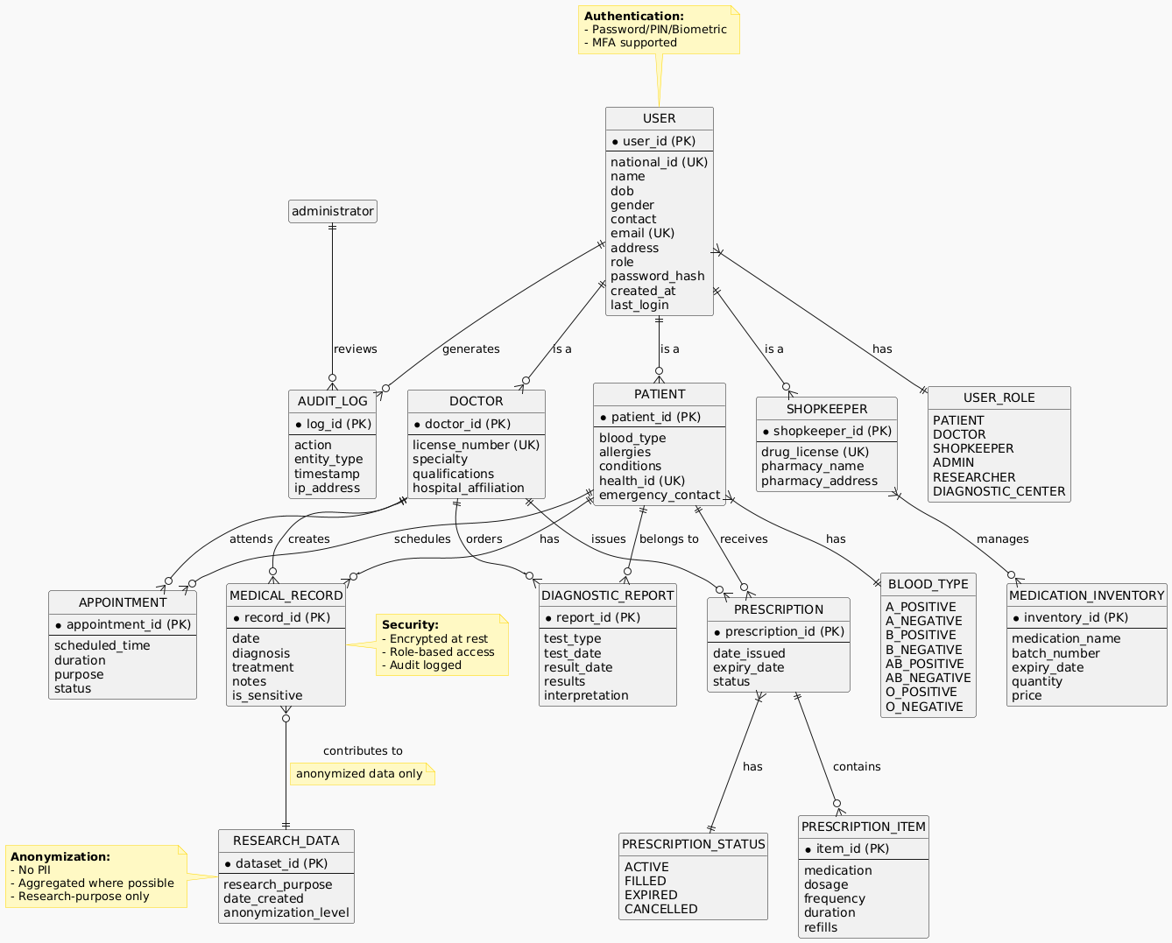
Figure 4.1: Logical entity-relationship view of the Health Data Bank

4.2 Data Dictionary
Entity | Data Element | Type | Meaning | Validation / Allowed Values
User | user_id | UUID / String | Unique internal user identifier | System generated; unique; required
User | role | Enum | Assigned role such as Patient, Doctor, Shopkeeper, Diagnostic Center, Researcher, Admin | Must match approved role list
User | nid_number | String | National ID used for identity verification where applicable | Protected; validated format; unique where used
User | email | String | Verified email address used for contact or authentication | Valid email format; unique where required
User | phone | String | Mobile/contact number | Bangladesh-compatible or approved international format
Patient | health_id | String | Unique Health ID linked to the patient | Required; unique; non-reusable
Patient | blood_group | Enum | Patient blood group | A+, A-, B+, B-, AB+, AB-, O+, O-
Patient | emergency_contact | String/JSON | Emergency contact name and phone | Optional but recommended; protected
Doctor | doctor_id | UUID / String | Unique doctor record identifier | Required; unique
Doctor | license_number | String | Professional/BMDC or approved registration number | Required for verification; unique
Doctor | specialty | String | Medical specialization | Validated text/value list
Pharmacy | license_number | String | Drug/pharmacy license number | Required for verified shopkeepers
MedicalRecord | record_id | UUID / String | Unique clinical record identifier | System generated; immutable identity
MedicalRecord | diagnosis | Text / Code | Diagnosis or condition information | Clinical entry; source and date required
MedicalRecord | record_date | DateTime | Date/time of clinical event | Required
Prescription | prescription_id | UUID / String | Unique digital prescription identifier | System generated; unique
Prescription | status | Enum | Prescription workflow status | ACTIVE, PARTIALLY_FILLED, FILLED, EXPIRED, CANCELLED
PrescriptionItem | medicine_name | String | Prescribed medicine name | Required
PrescriptionItem | dosage | String | Dose, frequency, and duration instructions | Required for active medicine
DiagnosticReport | report_id | UUID / String | Unique diagnostic report identifier | Required; unique
DiagnosticReport | report_type | String / Enum | Type of diagnostic test/report | Required
DiagnosticReport | file_reference | URI / Object Key | Secure pointer to uploaded report/image | Private object reference only
Appointment | appointment_id | UUID / String | Unique appointment identifier | Required; unique
Appointment | status | Enum | Appointment state | SCHEDULED, CONFIRMED, COMPLETED, CANCELLED, MISSED
Notification | notification_id | UUID / String | Unique notification identifier | System generated
Notification | delivery_status | Enum | Notification delivery state | QUEUED, SENT, DELIVERED, FAILED, READ
AuditLog | log_id | UUID / String | Unique audit entry identifier | Append-only; required
AuditLog | action_type | String / Enum | Action performed by a user/system | Required; controlled vocabulary
AuditLog | timestamp | DateTime | Time of audited activity | Required; server time
ResearchAccess | access_id | UUID / String | Unique approved research access record | Required for export/query audit

4.3 Reports
The system shall generate operational, clinical, administrative, audit, and research-oriented reports. Report access depends on user role and authorization.
- Patient Medical Summary Report: Displays selected demographic data, medical history, allergies, diagnoses, prescriptions, and diagnostic results for authorized clinical use.
- Prescription History Report: Lists prescriptions by date, doctor, medicine, dosage, and fulfillment status.
- Diagnostic Report History: Lists uploaded diagnostic reports, source center, report type, date, and version information.
- Appointment Report: Shows scheduled, completed, cancelled, and missed appointments by patient, doctor, date, or facility.
- Medication Reminder Report: Summarizes scheduled reminders and recorded taken/missed-dose information.
- User Activity Report: Shows login events, important account actions, and role-related system usage.
- Audit and Compliance Report: Summarizes access to sensitive medical data and administrative/security events.
- System Health Report: Displays availability, error, transaction, storage, and performance indicators for administrators.
- Research Aggregate Report: Provides anonymized counts, trends, and filtered statistics without personally identifiable information.
- Backup and Recovery Report: Records backup execution time, status, storage target, verification, and recovery-test information.
Where supported, reports shall be exportable in PDF and/or CSV format. Report exports shall include generation date, relevant filter criteria, and the identity/role of the requesting user where appropriate.

4.4 Data Acquisition, Integrity, Retention and Disposal
Data Acquisition: Patient identity data is entered during registration and verified through authorized identity channels. Clinical data is entered by authorized doctors, diagnostic data is uploaded by verified diagnostic centers, prescription information is created by doctors and fulfillment status is updated by approved medicine shopkeepers. System-generated timestamps, audit records, and notification records are created automatically.
Data Integrity: The system shall use validation rules, uniqueness constraints, referential integrity, versioning, controlled update permissions, and audit logging. Clinical records shall not be silently overwritten; critical corrections should retain the previous state or change history.
Data Synchronization: Authorized changes shall be synchronized in real time or near real time so that permitted users receive current information. Conflict handling and server-side transaction controls shall prevent partial updates.
Backup and Recovery: Critical application and database data shall be backed up regularly. The original SRS specifies frequent backup and recovery targets; production configuration shall use tested encrypted backups, redundancy, and documented disaster-recovery procedures.
Retention: Medical records, prescriptions, diagnostic reports, consent information, and audit records shall be retained according to applicable legal, clinical, and organizational requirements. The exact legal retention schedule must be confirmed before production deployment.
Disposal: When data is lawfully eligible for deletion, the system shall use controlled deletion procedures that account for active databases, cached copies, exported files, object storage, archives, and expired backup copies. Disposal of sensitive data shall be auditable.
Research Data: Research access shall operate on anonymized or aggregated copies/views. Researchers shall not receive direct identifiers and research exports shall be recorded and subject to approval rules.

5. External Interface Requirements

5.1 User Interfaces
The user interface shall be simple, readable, responsive, and appropriate for both technical and non-technical users. The updated prototypes below retain the original Health Data Bank concept while presenting a more consistent professional design for the final submission. UI prototype integration is credited to MD.Mahamodul Hasan Taj.
The login screen provides Health ID/National ID based sign-in, password entry, password recovery, and new-account navigation. It visually emphasizes secure access and a simple path for non-technical users.
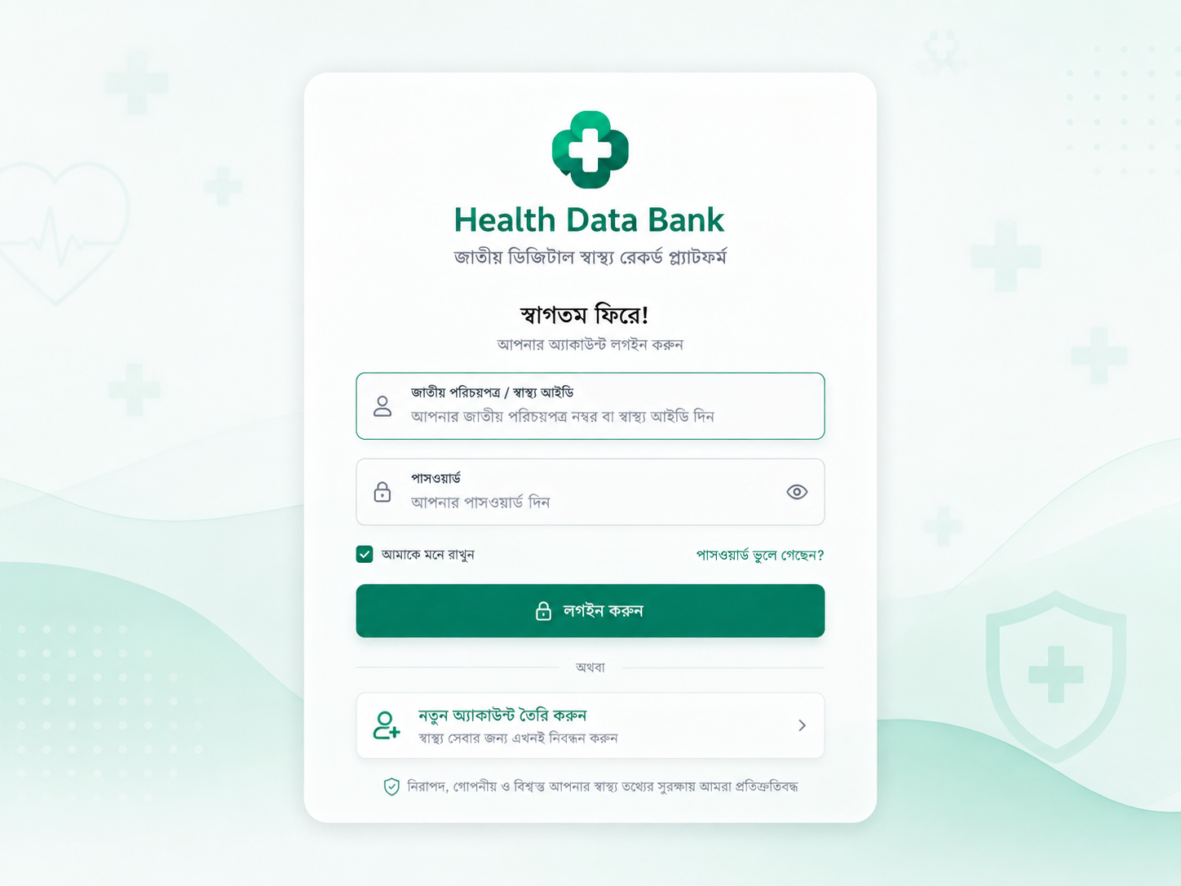
Figure 5.1.1: Updated Health Data Bank Login Prototype

The registration screen captures full name, username, National ID, mobile number, optional email, password, and gender while keeping the form readable and consistent with the Health Data Bank visual identity.
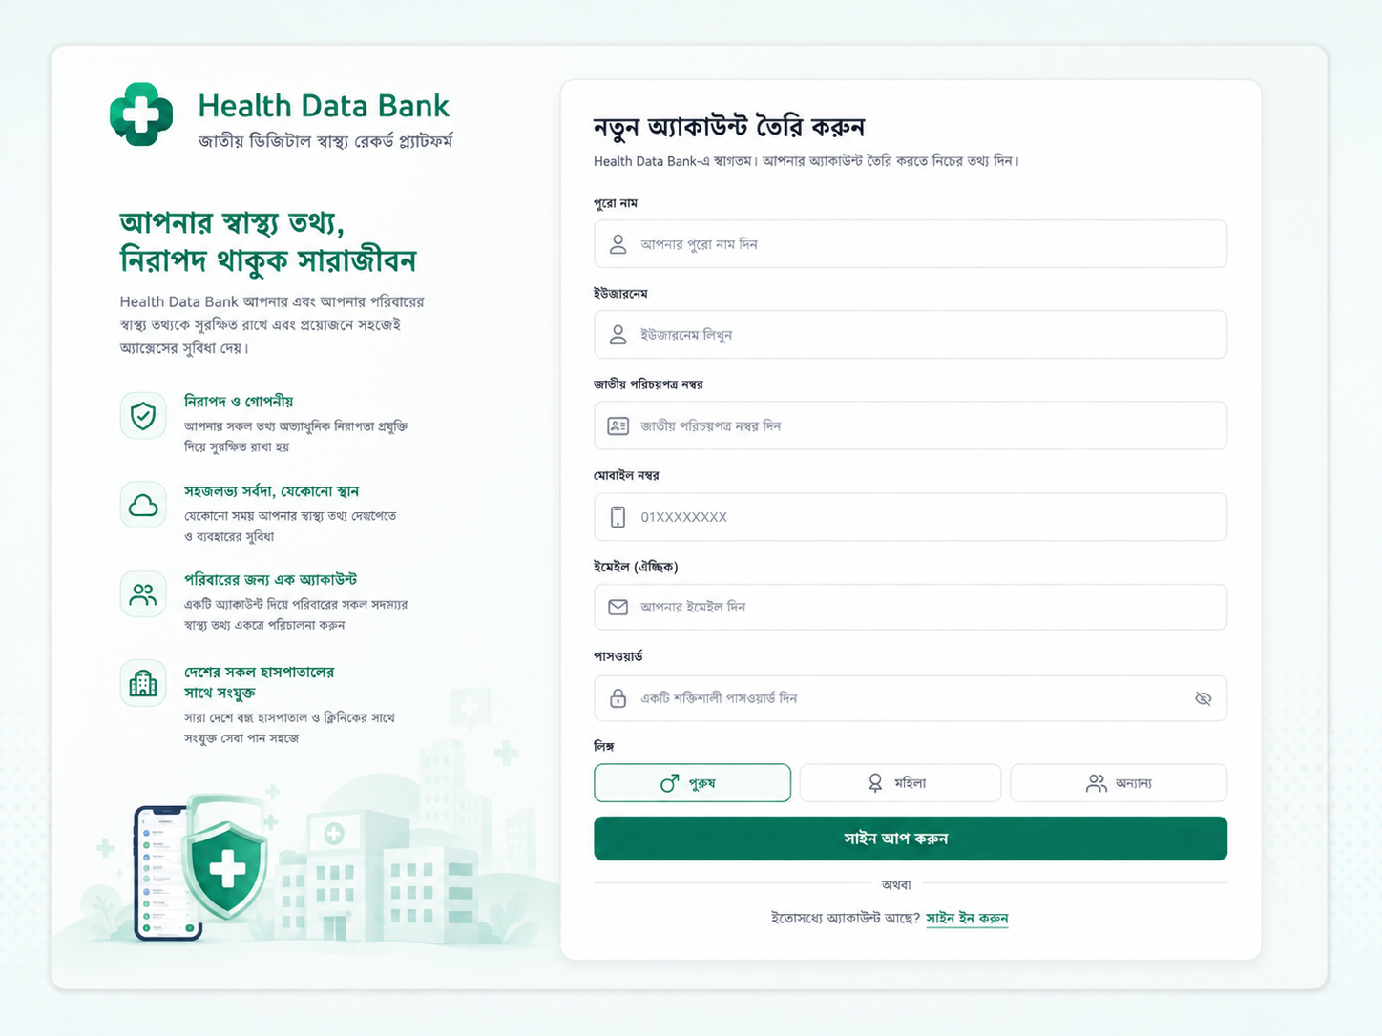
Figure 5.1.2: Updated Health Data Bank Registration Prototype

The password-recovery screen requests the registered email address and guides the user to the next recovery step with a clear path back to sign-in.
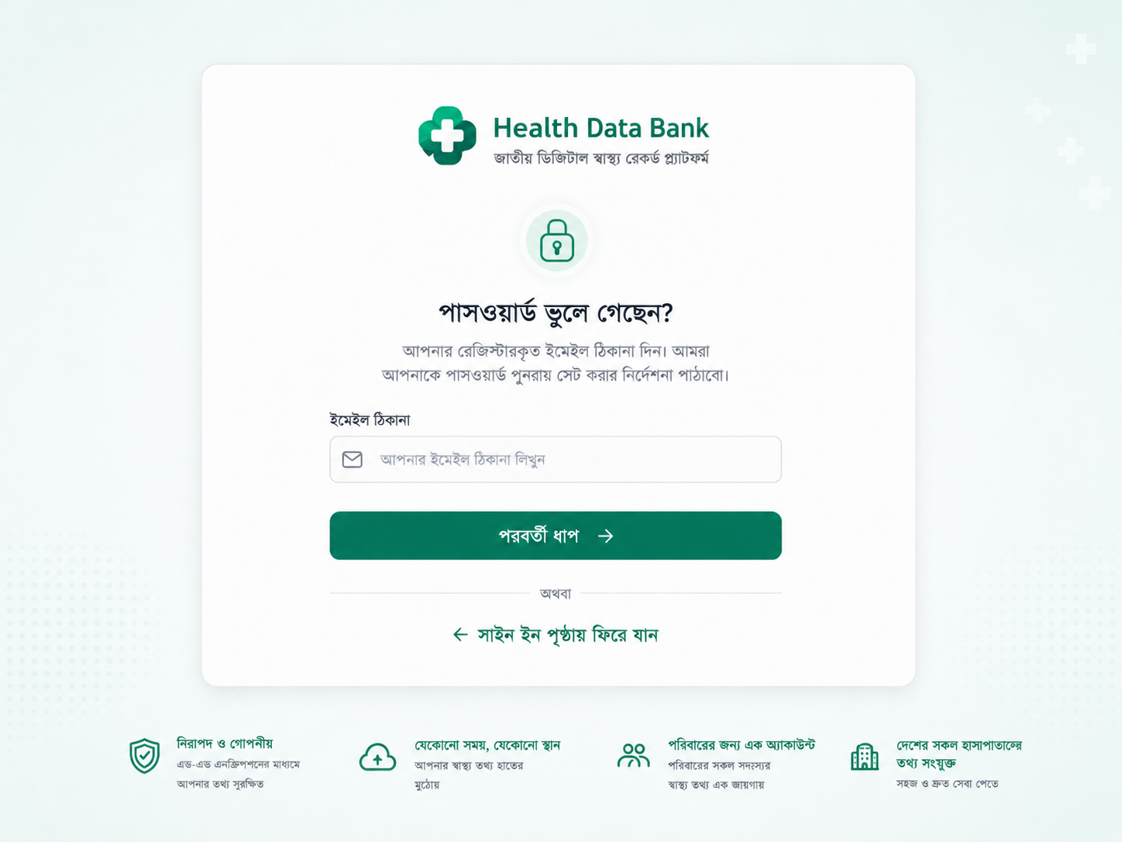
Figure 5.1.3: Updated Forgot Password Prototype

The patient dashboard provides a health summary, appointments, prescriptions, medical records, notifications, reminders, and profile information across desktop and mobile layouts.
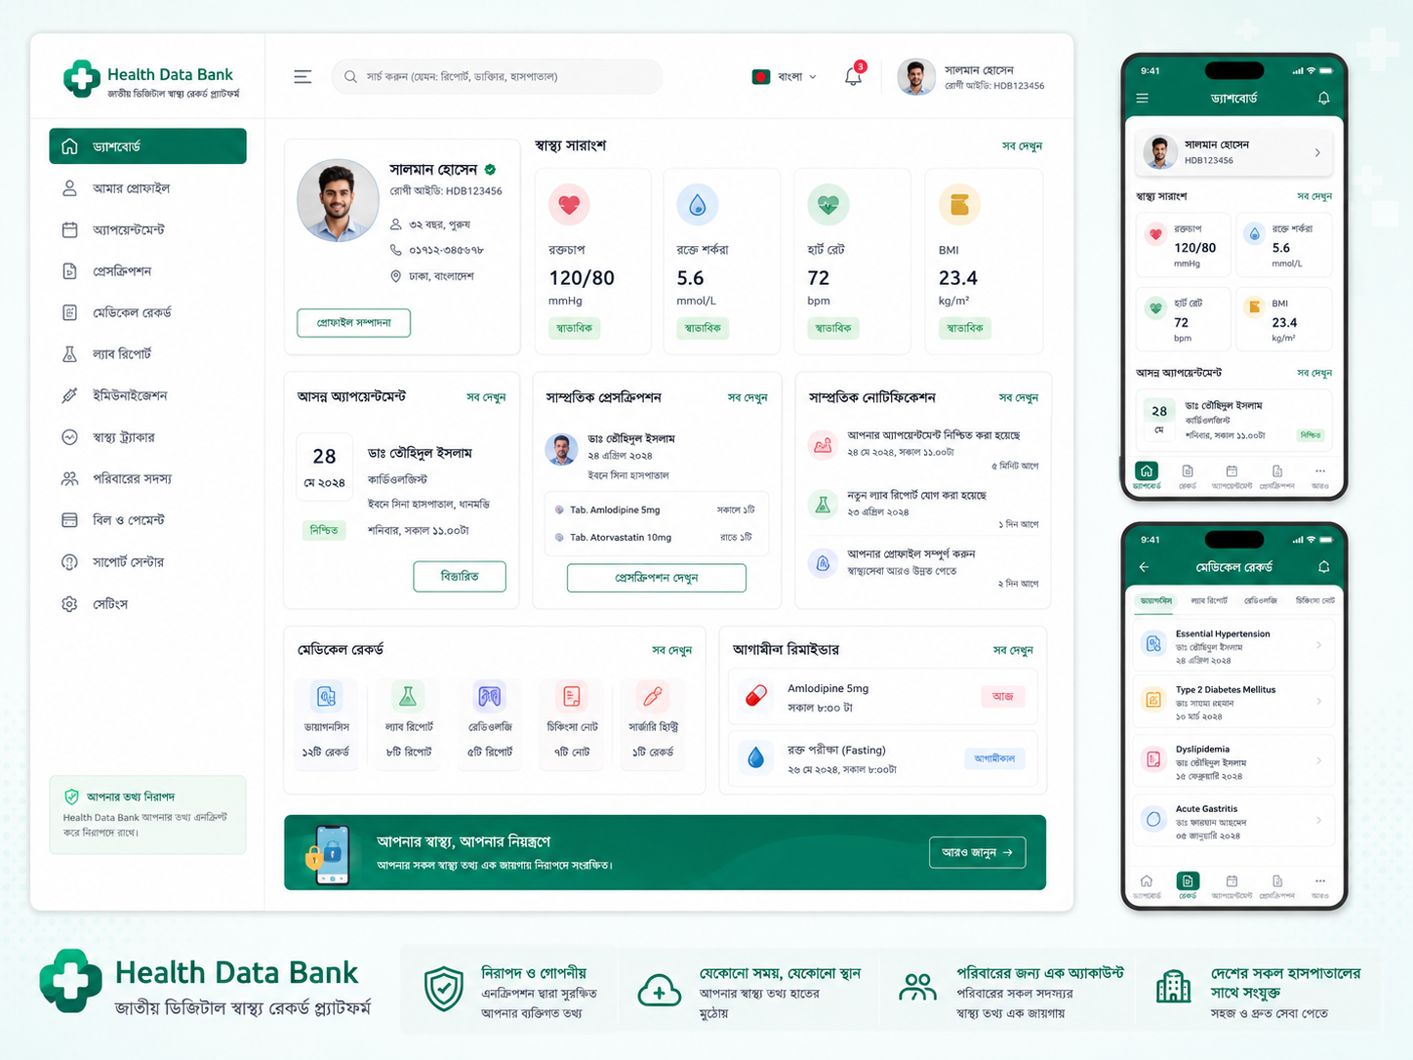
Figure 5.1.4: Updated Patient Dashboard Prototype

The doctor dashboard provides patient search, appointment workflow, quick patient information, digital prescription access, diagnostics, and clinical quick actions in a role-specific workspace.
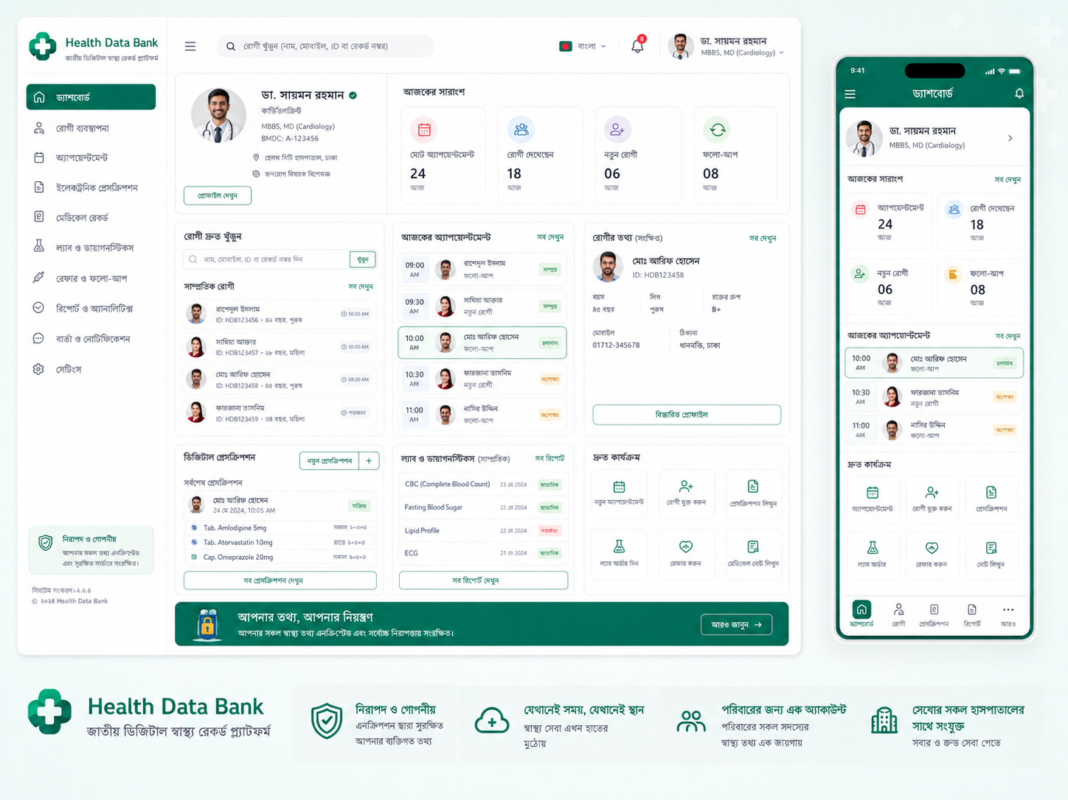
Figure 5.1.5: Updated Doctor Dashboard Prototype

5.2 Hardware Interfaces
- The system shall operate on desktop computers and laptops used by administrators, doctors, diagnostic centers, and researchers.
- The system shall support smartphones and tablets used by patients, doctors, medicine shopkeepers, and other authorized mobile users.
- Mobile device cameras shall be used to scan QR codes or Health ID information for patient identification where enabled.
- Centralized backend servers shall be used for application hosting, data processing, and secure storage.
- Network hardware such as routers, switches, firewalls, and load balancers shall support secure communication between users and servers.
- Storage servers or secure object-storage systems shall support medical documents and images.
- No specialized proprietary hardware is required for normal web/mobile operation, although facilities may deploy approved scanners, kiosks, or card readers.

5.3 Software Interfaces
- Operating Systems: Server-side Linux-based operating systems such as Ubuntu Server; client-side Windows, macOS, Android, and iOS.
- Database System: PostgreSQL shall store user information, medical records, prescriptions, diagnostic metadata, appointments, permissions, and audit logs.
- Web/Application Layer: Frontend and backend components shall communicate through authenticated RESTful APIs or equivalent secure service interfaces.
- Web Browsers: The web application shall support current versions of Google Chrome, Mozilla Firefox, Microsoft Edge, and Safari.
- Email/SMS Services: Approved gateway services shall deliver account verification, alerts, reminders, and administrative notifications.
- Cloud/Backup Services: Approved cloud storage may be used for encrypted backup and disaster recovery according to policy.
- Identity Verification: The system depends on an authorized National ID verification mechanism for Health ID linkage where integration is permitted.
- All software interfaces shall use secure authentication, validation, rate limiting, error handling, and logging appropriate to medical data.

5.4 Communications Interfaces
- The system shall use HTTPS for all client-server communication; unencrypted HTTP shall redirect to HTTPS or be disabled for sensitive operations.
- Sensitive data in transit shall be protected using current TLS protocols and approved cipher suites.
- RESTful API requests and responses shall use authenticated and validated message formats such as JSON where appropriate.
- Email, SMS, and push-notification services shall be used for appointment reminders, verification, alerts, medication reminders, and system notifications.
- Real-time or near real-time synchronization shall be supported for clinical record updates and relevant dashboard information.
- Communication failures shall use safe retry/error-handling logic and shall not create duplicate clinical transactions.
- Security-relevant communications and integration failures shall be logged for monitoring and audit.

6. Quality Attributes
The following nonfunctional requirements define the quality levels expected from the Health Data Bank. Requirements are stated so that they can be evaluated through performance testing, usability testing, security review, monitoring, or other verification activities.

6.1 Usability
- QA-U1: A trained user shall be able to complete common tasks such as viewing a medical record, booking an appointment, or locating a prescription within approximately three minutes under normal conditions.
- QA-U2: A new user shall be able to understand and navigate the primary functions with minimal training; the original SRS targets less than ten minutes for basic feature familiarization.
- QA-U3: The interface shall use consistent navigation, readable labels, clear confirmation messages, and understandable error messages.
- QA-U4: Patient-facing interfaces shall be appropriate for users with low technical expertise and shall avoid unnecessary clinical/technical complexity.
- QA-U5: The application shall aim to conform to WCAG 2.1 Level AA accessibility expectations, including keyboard accessibility, contrast, scalable text, and meaningful form labels.

6.2 Performance
- QA-P1: A trained user shall be able to retrieve common patient medical information within approximately 2 seconds for at least 90% of normal read actions under expected load conditions.
- QA-P2: The broader system objective is to return common medical records and diagnostics within 2–3 seconds in normal operation.
- QA-P3: The architecture shall support large numbers of concurrent users and shall scale horizontally or vertically as national usage grows.
- QA-P4: The original SRS identifies a peak-processing target of approximately 500 transactions per second for major infrastructure planning.
- QA-P5: System monitoring shall capture response time, throughput, error rate, and resource utilization for capacity planning and troubleshooting.
- QA-P6: Large diagnostic uploads shall not block unrelated interactive requests and should use controlled background/object-storage processing where appropriate.

6.3 Safety
- QA-SA1: The system shall prevent unauthorized users from accessing or modifying patient medical data.
- QA-SA2: The system shall protect critical medical information from accidental deletion and shall use backup/version history or controlled correction mechanisms where required.
- QA-SA3: The system shall distinguish clinical information from non-clinical wellness guidance and shall not present automated symptom suggestions as a substitute for professional medical diagnosis.
- QA-SA4: Controlled emergency access shall be logged and limited to information necessary for urgent care according to approved policy.
- QA-SA5: Critical alerts, failed data writes, and integrity failures shall be clearly reported to the appropriate user or administrator.
- QA-SA6: Safety-related actions such as prescription creation, report upload, and sensitive record modification shall retain source identity and timestamp.

6.4 Security
- QA-SE1: The system shall implement role-based access control for all user roles.
- QA-SE2: Sensitive medical information shall be encrypted at rest using approved strong encryption such as AES-256 or equivalent controls appropriate to the deployment environment.
- QA-SE3: All sensitive data transmission shall use TLS/HTTPS.
- QA-SE4: Administrator-level accounts shall require multi-factor authentication.
- QA-SE5: Passwords shall not be stored in plaintext; secure password hashing and modern credential-management practices shall be used.
- QA-SE6: Audit logs shall record login, data access, record updates, administrative actions, research access, and other security-relevant events.
- QA-SE7: Patient consent shall be enforced for protected data access except where an approved legal/emergency policy provides an alternative basis.
- QA-SE8: Research access shall use anonymized/de-identified data and shall prevent direct disclosure of personally identifiable information.
- QA-SE9: Sessions shall expire after inactivity and shall be invalidated on logout, credential reset, or account suspension.
- QA-SE10: The deployment shall use firewalls, monitoring, vulnerability management, backup protection, and restricted administrative access.

6.5 Reliability, Availability, Scalability, Maintainability and Portability
- Reliability: The system shall preserve data consistency and recover safely from common application, server, and network failures.
- Availability: The system target is 99.9% service availability excluding approved maintenance windows, corresponding to no more than approximately 8.76 hours of downtime per year.
- Fault Tolerance: Minor service failures should recover automatically within a short period, while major failures shall trigger administrator notification.
- Backup: Critical data shall be backed up on a regular schedule; the source SRS specifies frequent backups and a recovery objective measured in hours.
- Scalability: The architecture shall support growth in users, healthcare facilities, transactions, medical documents, and hundreds of millions of patient-related records.
- Maintainability: Modular architecture, clean coding conventions, documentation, automated testing, and clear APIs shall support future maintenance.
- Portability: The web application shall operate across major browsers and the mobile application shall support common Android/iOS environments.
- Device Compatibility: The application should remain usable on resource-constrained but supported mobile devices and standard desktop systems.
- Interoperability: External integrations shall use documented and secure interfaces so that national identity, hospital, notification, or research systems can be added without redesigning the entire application.

7. Internationalization and Localization Requirements
- The system shall support Bangla and English user-interface text so that it is usable by citizens and healthcare professionals with different language preferences.
- The user shall be able to change the application language without affecting stored clinical data or account identity.
- The system shall support Unicode throughout the application, database, reports, notifications, and exported files.
- Bangladesh-localized date, time, phone-number, and address formats shall be supported where appropriate, while storage should use unambiguous standardized formats internally.
- The system shall support local time zone handling for Bangladesh and preserve timestamp information when data is exchanged with external systems.
- Future localization shall allow additional languages without requiring major modification of business logic.
- Clinical codes, medicine names, and standard identifiers shall not be incorrectly translated; localized display text should preserve the underlying standard meaning.
- User manuals and major onboarding/help information should be available in Bangla and English for national deployment.

8. Other Requirements

8.1 Database Requirements
- The system shall use a centralized, secure database architecture for structured health and account information.
- Data integrity and consistency shall be maintained using primary keys, foreign keys, transactions, validation, and controlled update logic.
- The database shall support scalable indexing, partitioning, replication, archiving, and backup strategies appropriate to national-scale usage.
- Large files such as X-rays and scanned reports may be stored in secure object/file storage with protected database references rather than directly inside ordinary relational rows when that architecture is more appropriate.
- Database administrative access shall be restricted and logged.

8.2 Legal and Regulatory Requirements
- The system shall comply with applicable Bangladeshi laws, cybersecurity requirements, healthcare policies, professional regulations, and approved data-protection rules.
- Patient consent shall be required for normal access and sharing of protected medical data unless another lawful basis applies.
- Professional accounts shall be verified before being granted clinical or dispensing privileges.
- Audit records shall be retained as required for investigation and compliance review.
- Production deployment shall obtain legal and policy approval for National ID integration, research data use, emergency access, retention periods, and cross-institution data sharing.

8.3 Backup, Recovery, Audit and Compliance
- Automated backups shall be scheduled and monitored, with encrypted copies maintained in approved separate locations.
- Disaster recovery procedures shall be documented and tested so that critical service can be restored within the approved recovery objective.
- Audit logs shall be tamper-resistant and shall record the user, action, object/record, time, and relevant source/session context.
- Administrators shall be able to generate compliance reports and review critical access activity.
- Backup recovery tests and disaster-recovery exercises shall be documented.

8.4 Project Requirements and Management
The original Health Data Bank SRS also included project planning information. The following details are retained as project-level requirements and estimation assumptions for the academic SRS.
Effort Estimation Method: COCOMO (Constructive Cost Model) is used as the academic estimation model. The original exercise assumes an estimated software size of 30 KLOC and uses embedded-project constants a = 3.6 and b = 1.20.
Estimated Effort: The original SRS reports approximately 213.23 person-months for the selected estimation assumptions.
Estimated Timeline: The original SRS uses an approximately 8.5-month project timeline for the assumed staffing model.
Human Resources: Representative roles include project manager, software developers, QA engineers, UI/UX designers, system administrator, and technical writer.
Project Management Tool: JIRA is used for project management, task assignment, member responsibility tracking, task status, and estimated time management.
Supporting Tools:
- Selenium for automated functional testing and cross-browser verification.
- GitHub/GitLab for source control and collaboration.
- Docker/Kubernetes for containerization and orchestration when required.
- Postman for API testing.
- Team communication and documentation tools as selected by the project team.
External Services:
- Secure hosting infrastructure such as approved on-premises, government-controlled, or cloud environments.
- National ID/identity verification integration subject to authorization.
- Email and SMS gateways for notifications.
- Secure backup/disaster-recovery storage.
- Support and maintenance services for production operation.

Appendix A: Glossary
Term | Description
Health Data Bank | A centralized digital system for storing and managing citizens’ medical records.
Health ID | A unique health identification number assigned to a patient and linked to the National ID according to the system concept.
SRS | Software Requirements Specification.
RBAC | Role-Based Access Control.
Admin | System administrator responsible for user, permission, security, monitoring, and system-management functions.
Patient | End user who owns and accesses personal medical information.
Doctor | Authorized healthcare professional who accesses permitted patient history and creates or updates clinical information.
Diagnostic Center | Authorized healthcare entity that uploads test reports and diagnostic results.
Shopkeeper | Authorized medicine seller/pharmacy user who verifies and dispenses prescriptions.
Researcher | Approved user who accesses anonymized or aggregate medical data for research purposes.
API | Application Programming Interface.
HTTPS | Secure HyperText Transfer Protocol using TLS.
Encryption | Technique used to protect information against unauthorized disclosure.
Audit Log | A traceable record of system activity used for monitoring, investigation, and compliance.
MFA | Multi-Factor Authentication.
PII | Personally Identifiable Information.
NHR | National Health Registry; the centralized registry concept represented by the Health Data Bank.
WCAG | Web Content Accessibility Guidelines.
COCOMO | Constructive Cost Model used for software effort estimation.

Appendix B: Analysis Models
The following analysis models illustrate major actors, system behaviors, domain classes, workflow, and database relationships. For this final submission, the diagram contribution is assigned to MD.Mahamodul Hasan Taj.
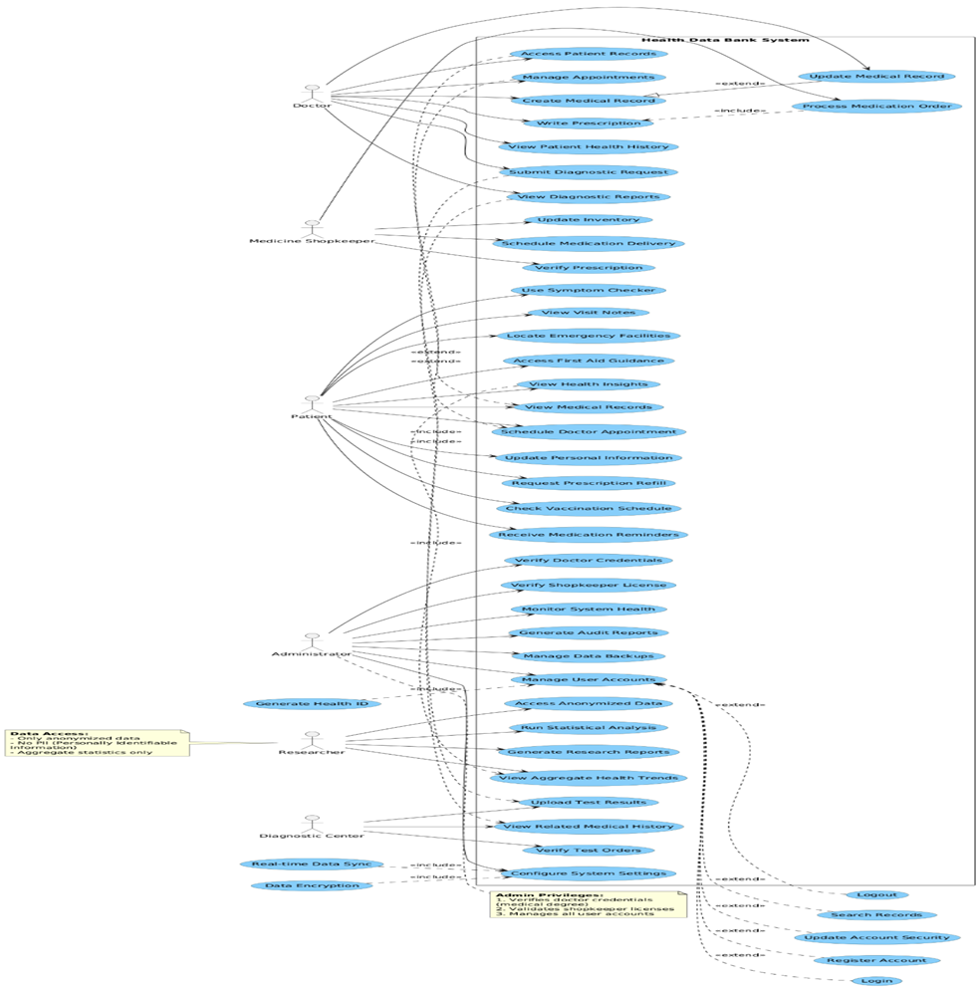
Figure B.1: Use Case Diagram

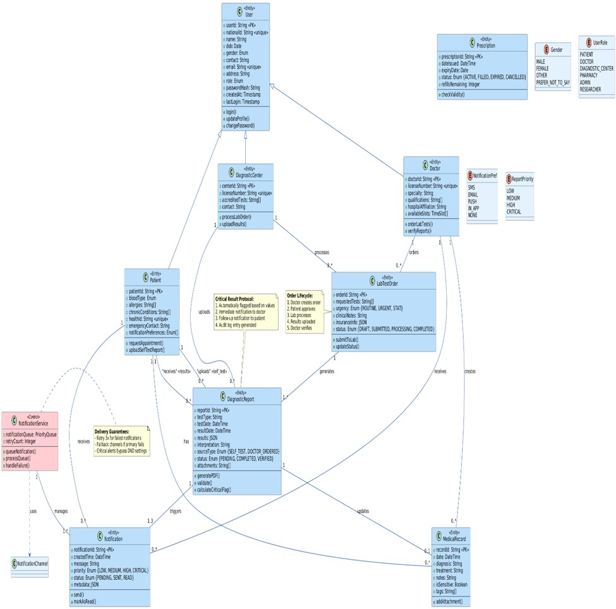
Figure B.2: Class Diagram
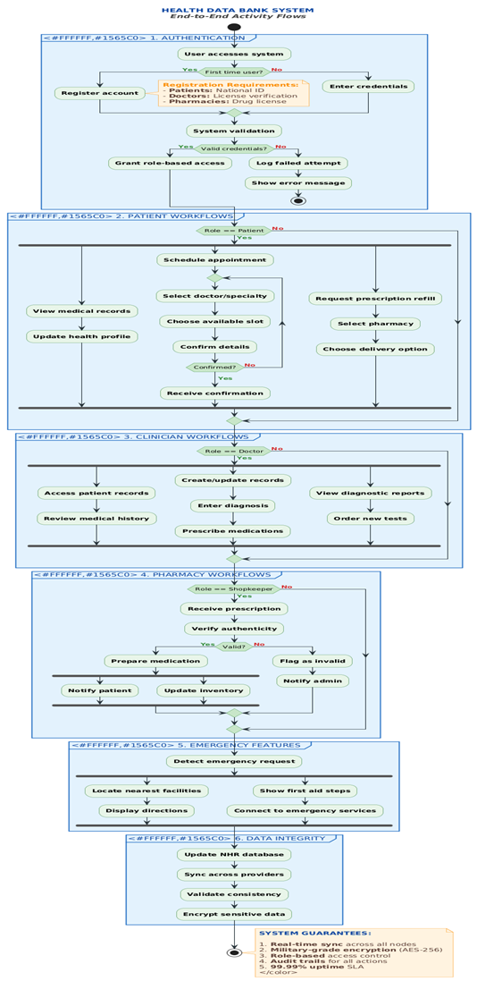
Figure B.3: Activity Diagram
Diagram Contribution: MD.Mahamodul Hasan Taj

Figure B.4: E-R Diagram

Appendix C: To Be Determined List
- TBD-1: Final authorized integration method and API contract for National ID verification.
- TBD-2: Exact national legal retention periods for each category of medical and audit data.
- TBD-3: Final production hosting model (government/on-premises/private cloud/hybrid) and detailed infrastructure capacity.
- TBD-4: Final data-sharing and emergency-access policy approved by the relevant health and legal authorities.
- TBD-5: Final research-approval workflow and statistical disclosure controls for anonymized exports.
- TBD-6: Final notification gateway providers, service-level agreements, and national-scale delivery limits.
- TBD-7: Final interoperability standards and API specifications for hospital, diagnostic, pharmacy, insurance, and research-system integration.

